Name: - Mohan Uday Kabade
Class: BTech AIDS-A
Roll No: - 71
PRN: - 12210457 subject : Introduction to LLM
LLM Assignment No.1

Q1) Explain the working principle of a perceptron with a suitable diagram and example.
A Perceptron is the most basic building block of a neural network — often called an artificial neuron.It was first introduced by Frank Rosenblatt in 1958 and is mainly used for binary classification, i.e. deciding between two possible outcomes (like yes/no, 0/1, spam/not spam).

Structure of a Perceptron
A perceptron consists of:
- Inputs (x₁, x₂, …, xₙ) – the features or attributes.
- Weights (w₁, w₂, …, wₙ) – represent the importance of each input.
- Summation Function – adds up all weighted inputs.
- Activation Function – decides the final output (usually 0 or 1).
- Bias (b) – allows the model to shift the decision boundary.
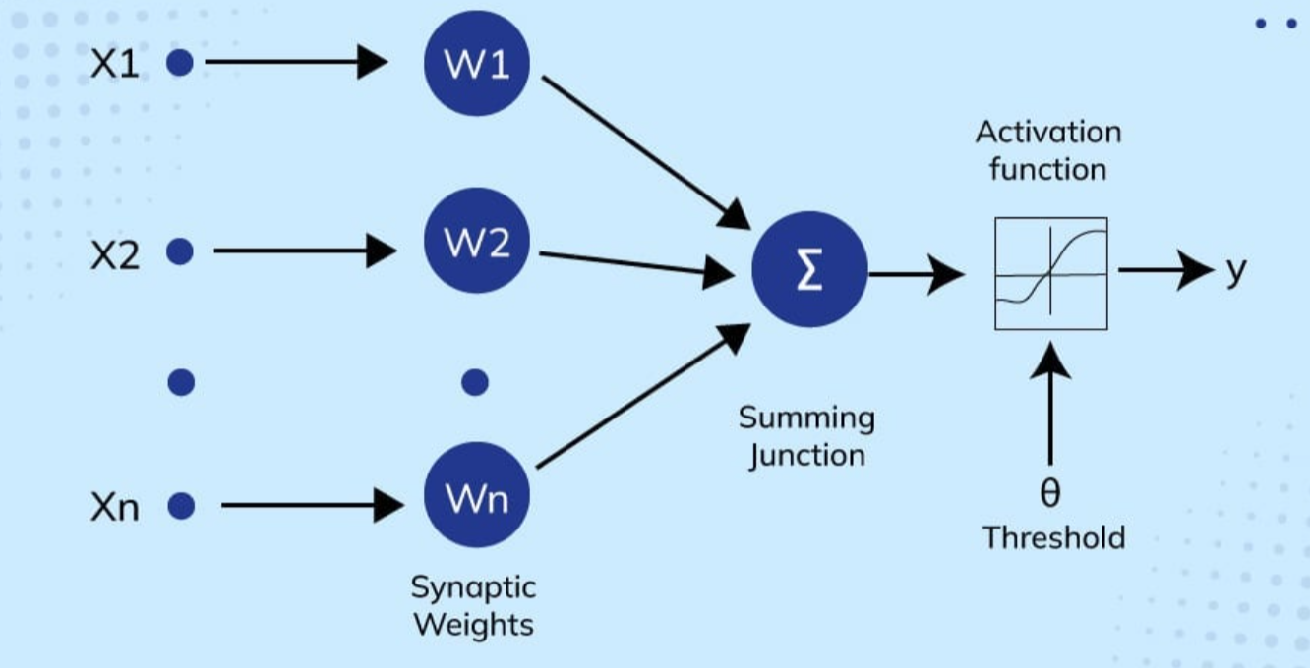
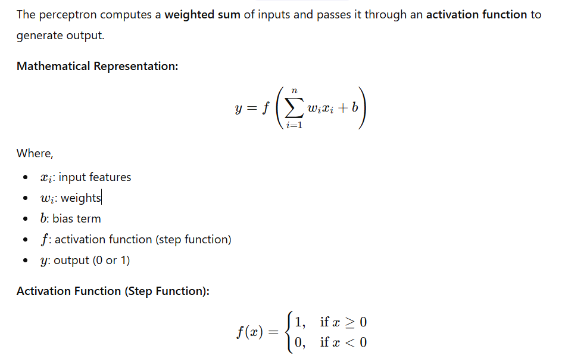

Example
Let’s take a simple OR Gate example.
Input x₁ | Input x₂ | Desired Output (y)
0 | 0 | 0
0 | 1 | 1
1 | 0 | 1
1 | 1 | 1
Let:
- w1 =1
- w2 =1
- b=−0.5
z=w1 x1 +w2 x2 +b
x₁ | x₂ | z = x₁ + x₂ - 0.5 | Output (f(z))
0 | 0 | -0.5 | 0
0 | 1 | 0.5 | 1
1 | 0 | 0.5 | 1
1 | 1 | 1.5 | 1

Hence, the perceptron successfully models an OR gate.

Q2) Implement a simple feedforward neural network (ANN) for binary classification using NumPy (without any deep learning library).
A Feedforward Neural Network (FNN) is the simplest type of Artificial Neural Network.
In this network, data moves only in one direction — from input → hidden layer(s) → output — without any feedback connections.

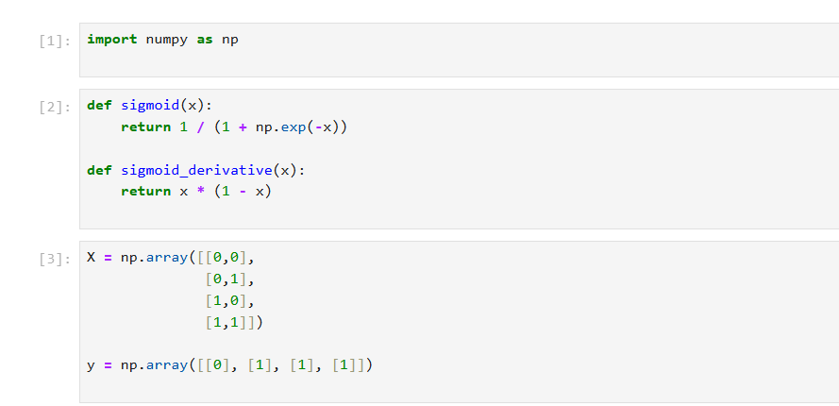
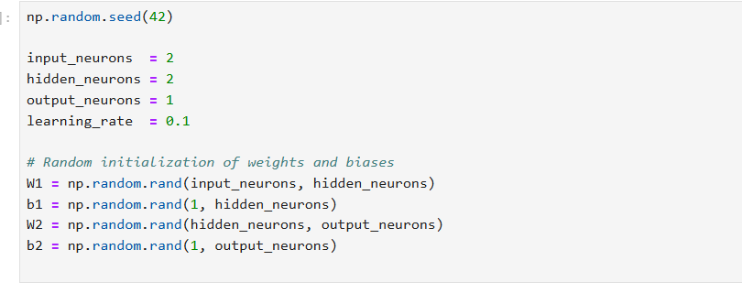
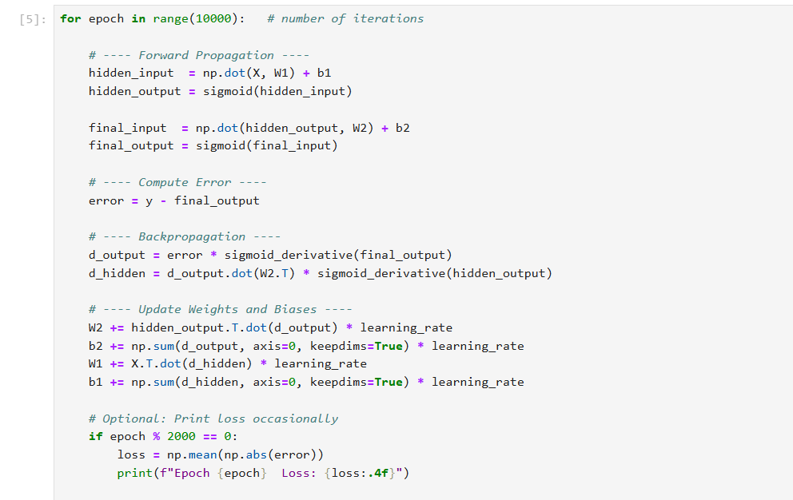

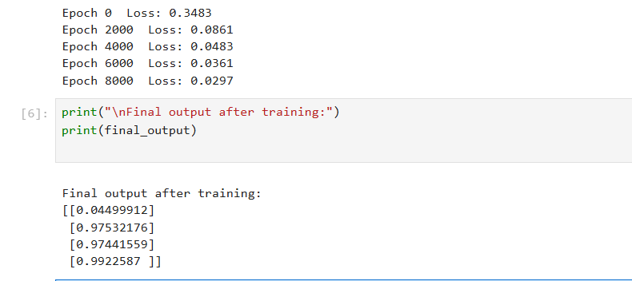
The results are near to 0, 1, 1, 1 which correctly models the OR logic gate.

Q3) Demonstrate the backpropagation algorithm step by step for a 3-layer ANN.
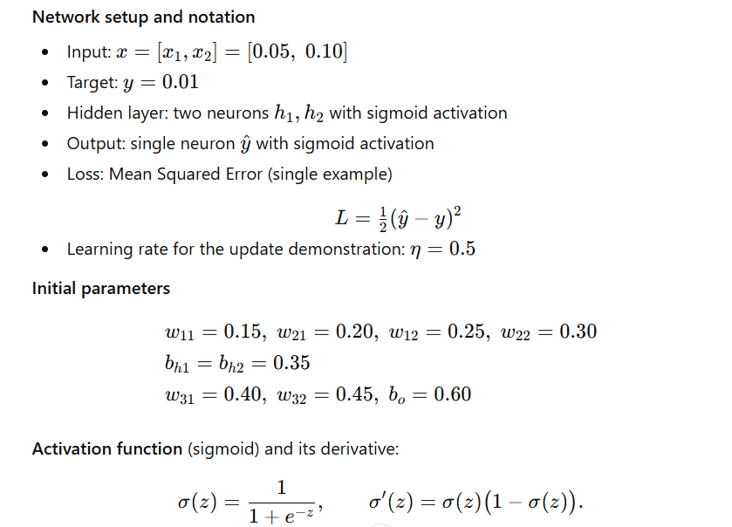
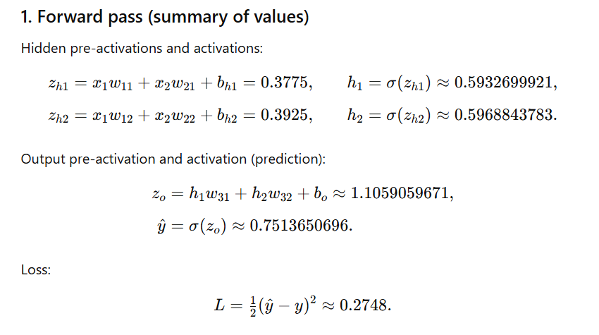
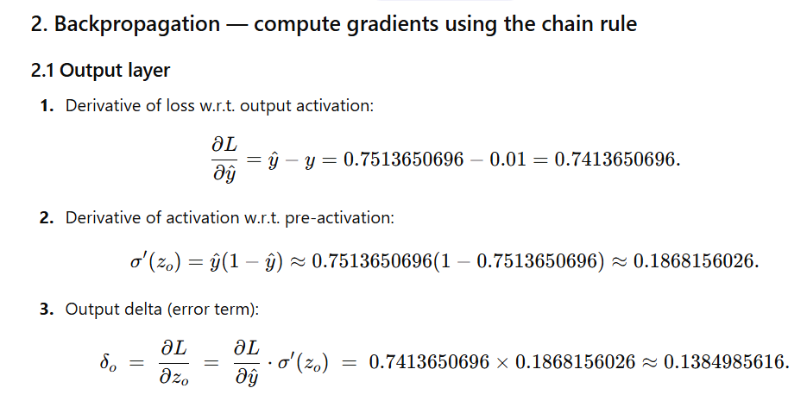
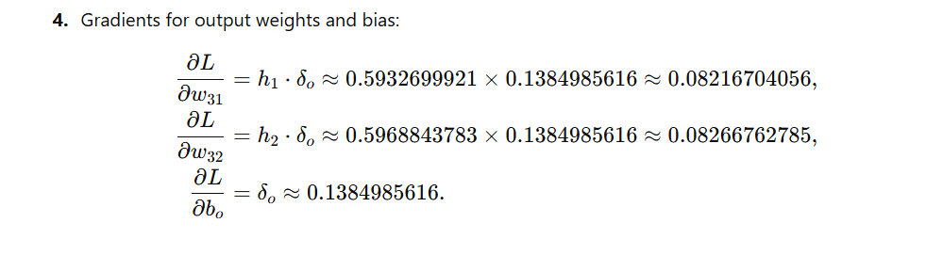
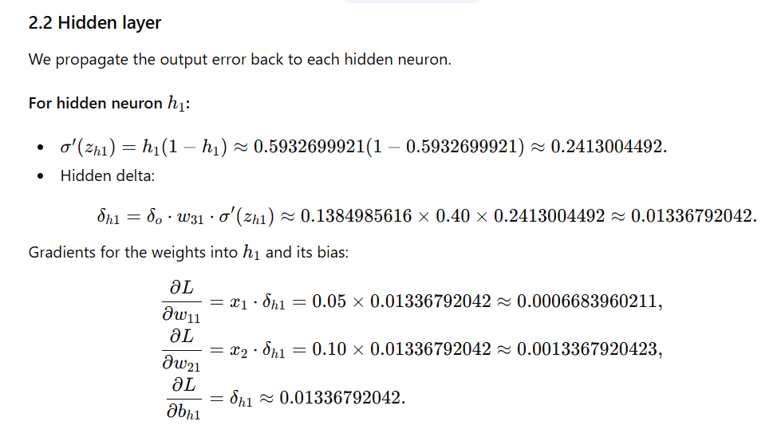
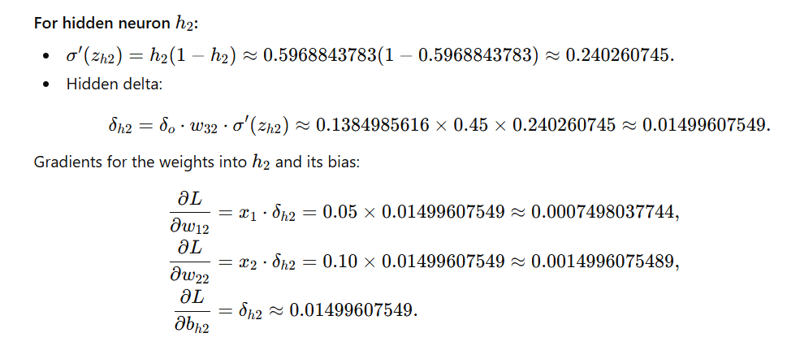
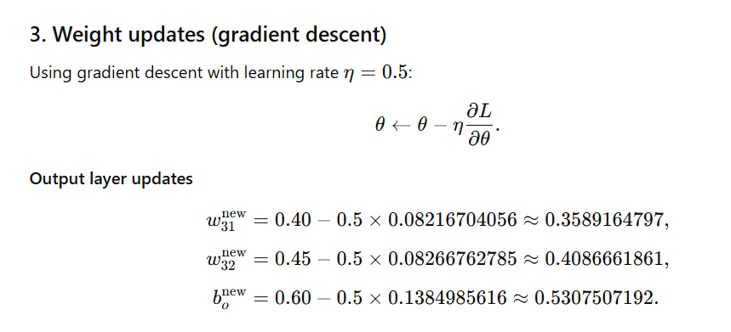
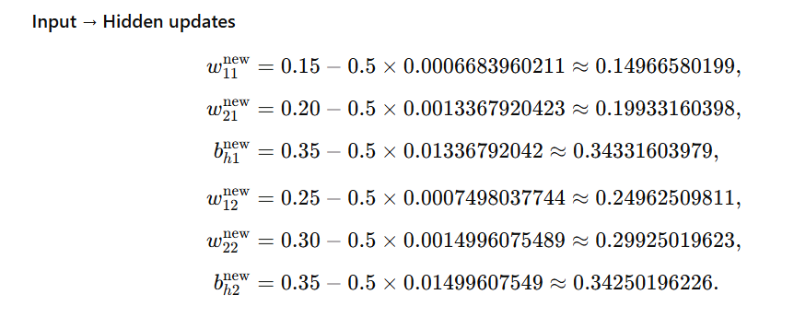
Q4) Implement a simple CNN for MNIST digit classification using PyTorch.
A Convolutional Neural Network (CNN) is a type of deep learning model widely used for image classification and computer vision tasks.
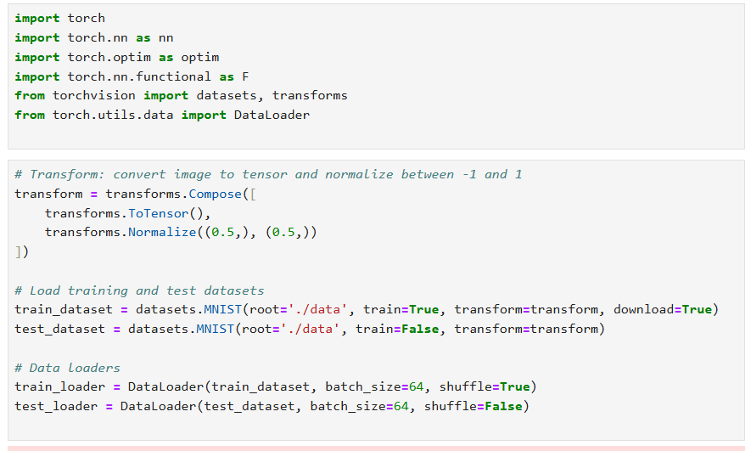
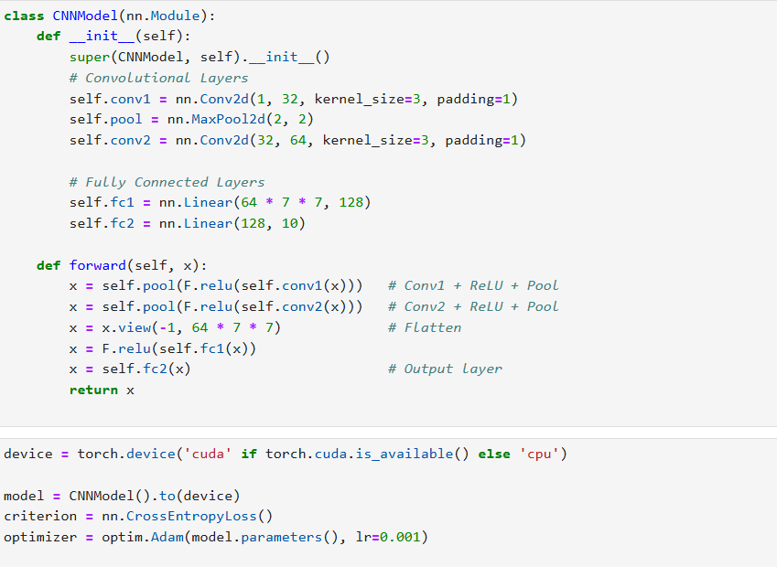

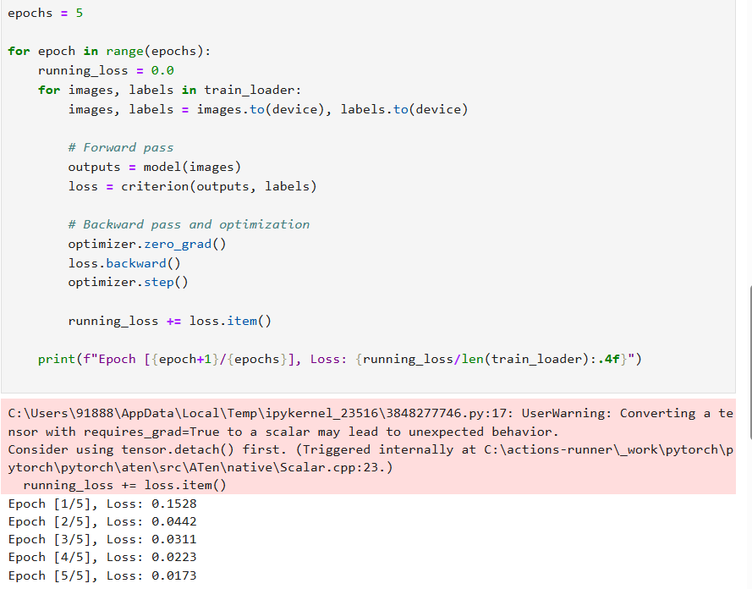
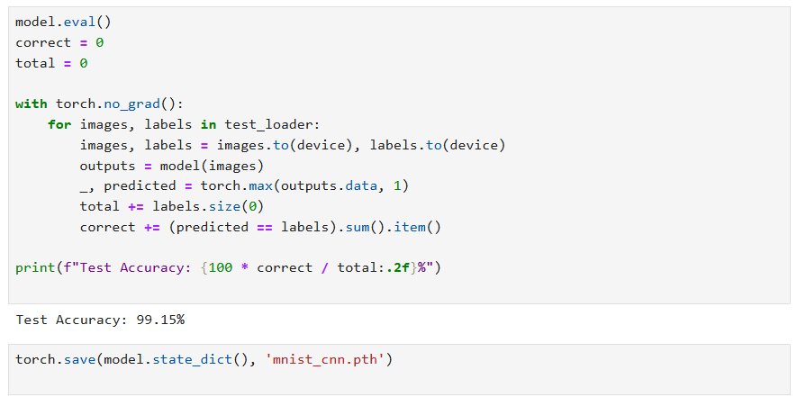
Q5) Write a short note on the advantages of CNN over fully connected networks.

Advantages of CNN over Fully Connected Networks
- CNNs use local connections and shared weights, reducing the number of parameters and making training more efficient.

- They can automatically learn spatial features like edges, textures, and shapes from images.

- CNNs provide translation invariance, allowing them to recognize objects even when their position varies.

- They offer better generalization and are less prone to overfitting compared to fully connected networks.

- CNNs are computationally efficient and perform well on large image datasets using GPUs.

- Overall, CNNs achieve higher accuracy and performance for visual data than traditional fully connected neural networks.

